Density-Driven Currents

Objective: To demonstrate density differences in ocean and coastal waters, and how these differences drive currents.

Background
Circulation in estuaries and oceans depends in part on differences in density of the waters. Water with more salt is heavier and sinks while fresher water is lighter and “floats” on the surface. These buoyancy differences result in the separation of water into layers (stratification) within an estuary or coastal ocean. Stratification can be disrupted by heating and cooling of surface waters and/or by wind-generated water movement like waves and currents. The primary source of fresh water in estuaries and coastal oceans is from rivers coming from land with a rating of 0-5 practical salinity units (PSU), while salt water is from the open oceans and has a rating of 32-35 PSU. In this simulation we will observe what happens when simulated river water (clear) is mixed with simulated ocean water (dyed blue).

Materials
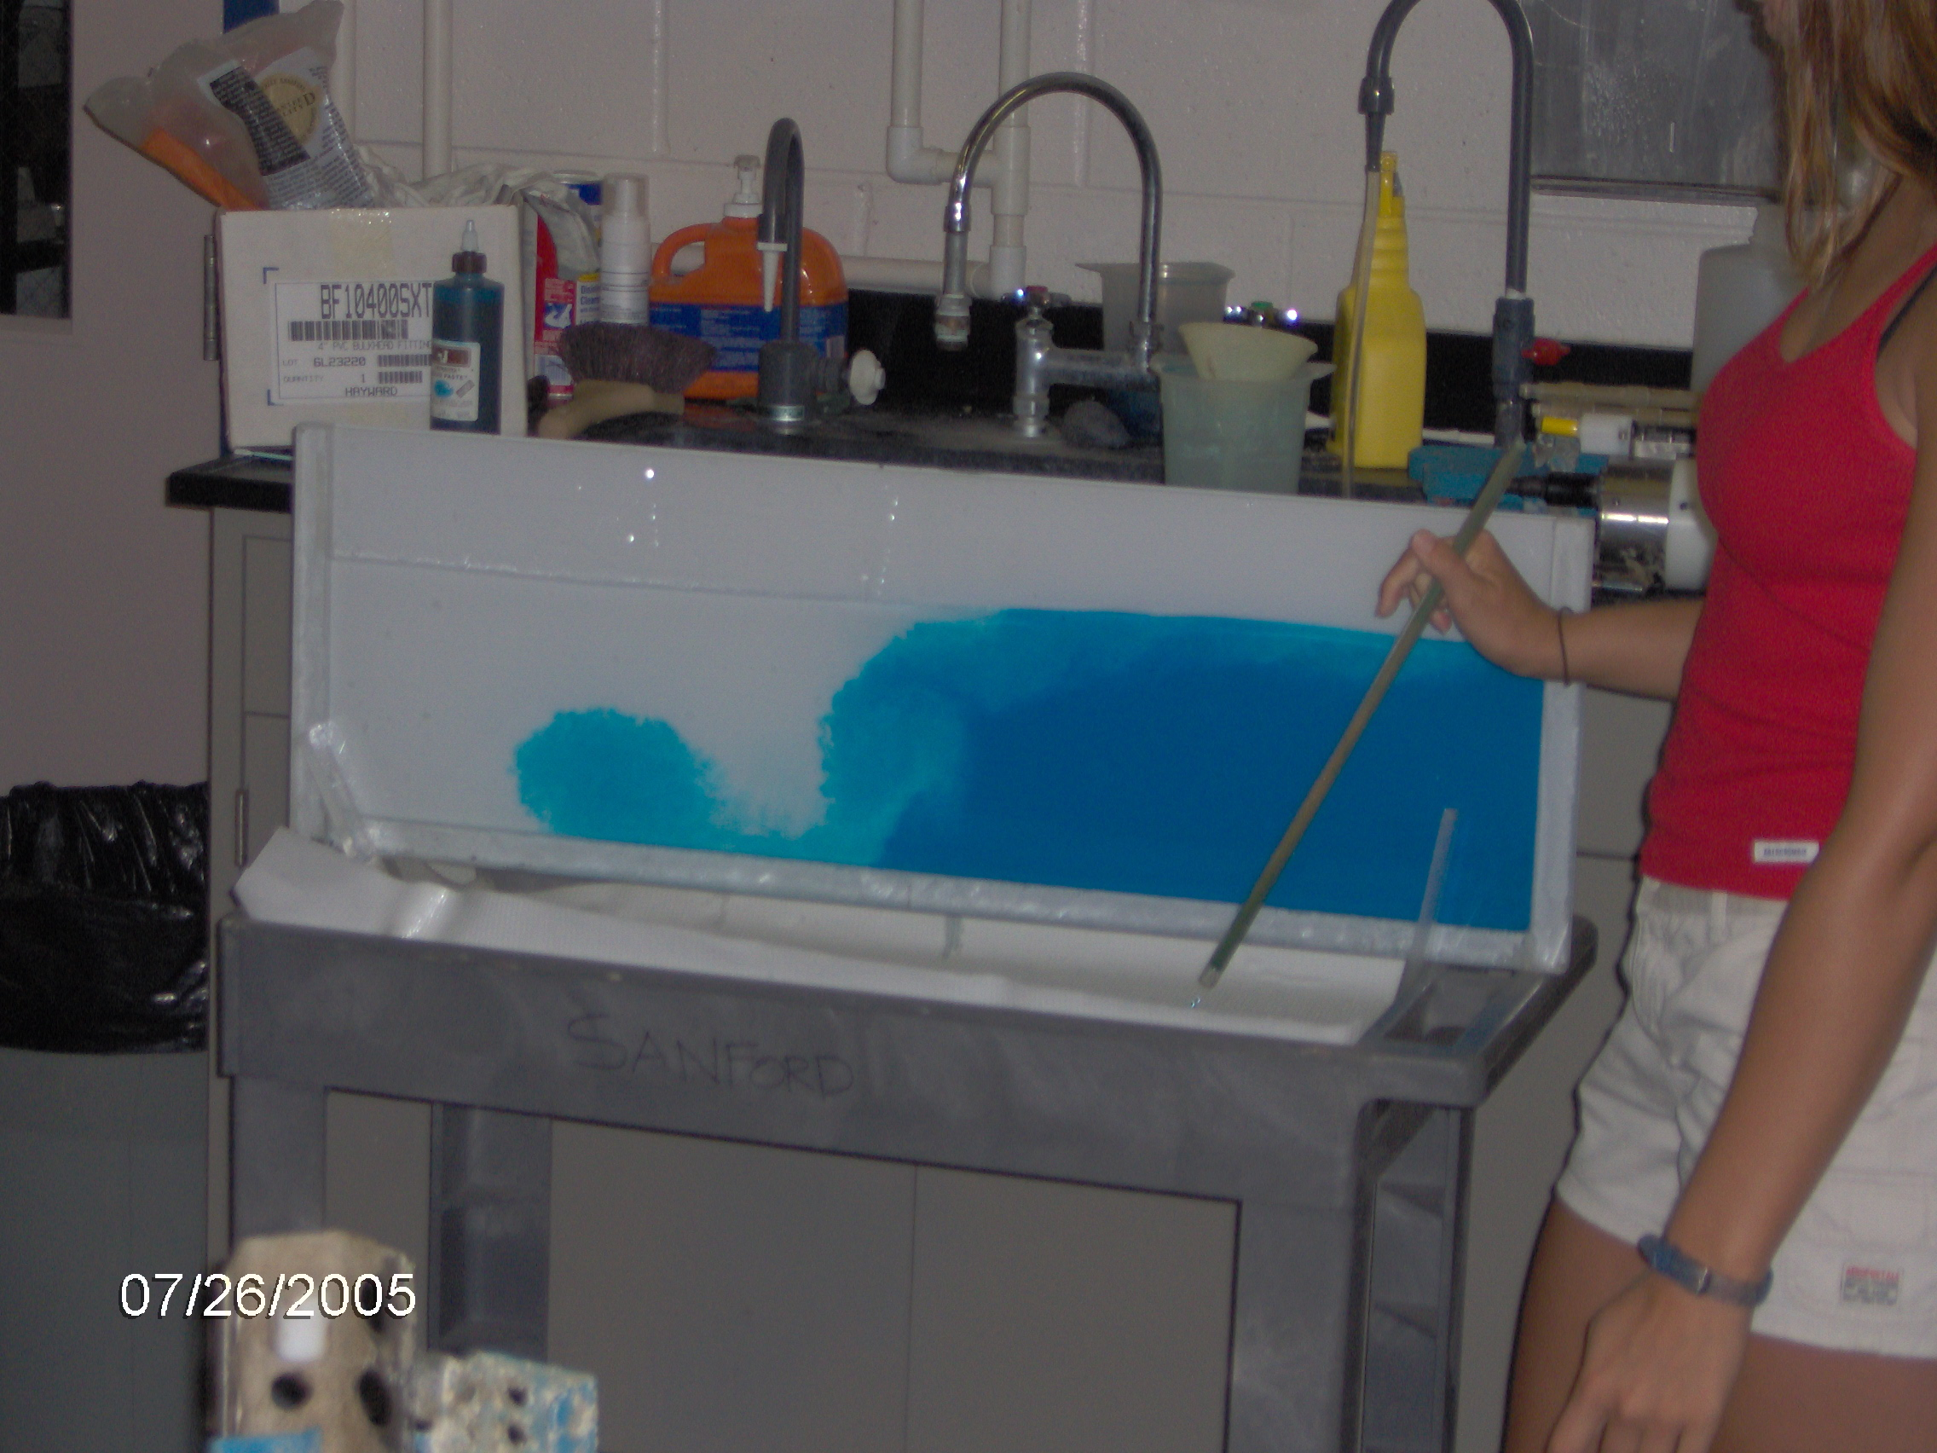
Glass or clear plastic tank
Food coloring
Water
Salt (kosher salt works best)
Straw
Worksheet

Procedure
Part 1

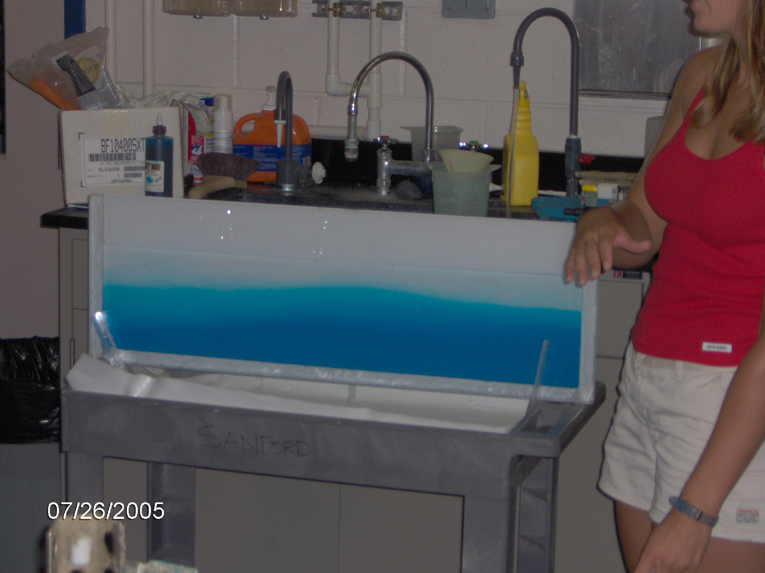
1. Measure 1 liter of tap water (to simulate river water) into a beaker or similar vessel. Add red or yellow food coloring if you want.
2. Repeat this step, except to this second beaker, add blue dye and add 10 grams of table salt (to simulate ocean water).
3. Set up tank with a divider in the middle. The divider should be cut to fit the width of the aquarium. Use ¼ inch durable plastic or glass.
4. Slowly pour the “river” water into one side of the demonstration tank and the “ocean” water to the other side. Fill tank about half full and remove the divider.
5. Record observations on the worksheet.

Part 2

- Blow on the surface of the water through a straw.
- Record observations on the worksheet.

Worksheet: Density-Driven Currents

Part 1

After adding the fresh and salty water to the tank:

1) Which water had a higher density?

2) What happened to the two water masses?

Part 2

After blowing on the surface of the water through a straw:

3) What happens to the two layers of water?

4) What happens when the wind stops?

5) How does this apply to the real world in coastal waters?

