Land-Water Connection Student Worksheet
Instructions: You will be assigned a water year set. Set 1 is 2009/2011 and Set 2 is 1988/2002. While completing this activity (steps 1-3), you only need to analyze your water year.
Assigned Water Year Set: _________________
Step 1: Land Cover
Hypothesize: How do you think land cover has changed in the Greensboro Watershed? Why?

Instructions-Click on the picture below for a link to your water year set and observe the land cover change between 2009/2011 OR 1988/2002.
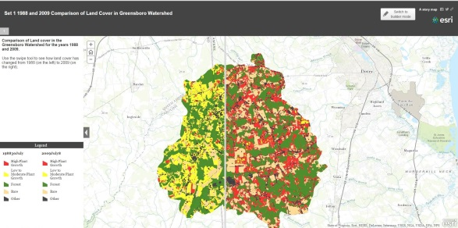
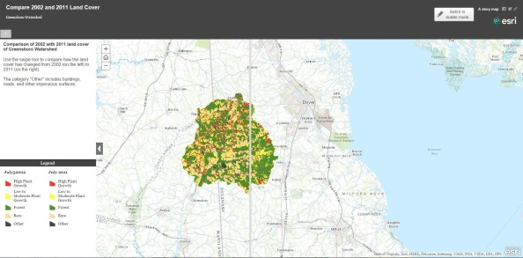

Set 2
Set 1

In your map, what is meant by the “Other” category?

How did the land cover change?

Step2: Weather Data
Hypothesize: how can weather affect water quality?

Instructions: Look at your climate graphs for Set1: 2009/2011 OR Set 2: 1988/2002. Compare the two years.
What year had higher precipitation totals?

How did precipitation patterns change throughout the seasons? Use data from each year to explain.
Year:_______
Year:_______
What year had higher maximum temperatures?

How did the years compare to the Dover, Delaware norms?

What was the difference between the two water years and how did each year differ from a normal year? Does the weather data support what you observed in the land cover maps? Explain.

Step 3: Pollutants
Hypothesize: Based on what you’ve learned about change in land cover and the weather for your two years, what do you think the trends are for nitrate and phosphate pollution? Explain.

Instructions: Look at the pollutant graphs (“Nitrate, Phosphate Levels for Water Year XXXX).
What is the relationship between nitrate levels and phosphate levels?

Why are there fluctuations in nitrate levels throughout the year? (Look at the maximum and minimum concentrations)

Why are there fluctuations in phosphate levels throughout the year? (Look at the maximum and minimum concentrations)

Compare the nitrate and phosphate concentrations for your two years. What patterns do you observe?
Step 4: Comparing the years
Instructions: meet with another group that looked at the other set of data (2009/2011 or 1988/2002).
What patterns do you observe between the different water years?

Based on the data, what do you think has caused the increase of pollutants into the Greensboro Watershed? (Claim, Evidence, Reasoning)

Propose at least 3 ways to mitigate or prevent Nitrate and Phosphate pollution from contaminating the Greensboro watershed.

