Hypoxia in the Chesapeake Bay : Causes and Effects

Source: http://teachoceanscience.net/teaching_resources/education_modules/dead_zones/learn_about/

July 21, 2016

What is the “Dead Zone”?  In coastal marine environments, “Dead Zones” are regions where oxygen concentrations are very low. This condition of oxygen deficiency, known as hypoxia, is caused by an interaction between biological, chemical and physical factors. In the absence of sufficient oxygen, animals and plants either die or leave the dead zone. Although these affected waters are called dead zones, many bacteria can thrive in this region, feeding on the abundant food produced in the overlying waters. Hypoxia is a natural phenomenon that occurs periodically in coastal waters around the world. During the last 50 years, however, increases in key pollutants derived from human activities on land have thrown many coastal ecosystems out of balance, resulting in expanded dead zone regions. | What are dead zones?  What causes hypoxia?  Why is an increase in hypoxia seen over last 50 years?
Dead Zones occur around the world in both fresh and saltwater systems like Lake Erie, Chesapeake Bay, northern Gulf of Mexico, and the Baltic Sea. Although Dead Zones occur naturally in some coastal area, the frequency and duration of hypoxia is increasing worldwide, especially in coastal waters adjacent to densely populated watersheds. | Where do they occur?  What is the relationship between population and dead zones?
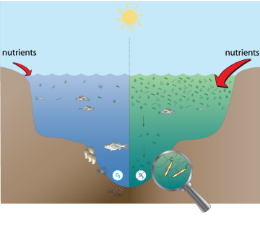 | Compare and contrast the processes that are happening on each side of the picture
How does a “Dead Zone” form in Chesapeake Bay?  Many coastal waters like Chesapeake Bay are susceptible to the formation of dead zones due to a combination of biological and physical factors. First, nutrients from agriculture and urban development within the Bay’s watershed, or the area of land that drains into a body of water, are washed into the Bay in excess quantities. These excess nutrients fertilize the rapid growth of microscopic plants, called phytoplankton, in a process known as eutrophication. When the phytoplankton use up all the nutrients, they die and sink to the bottom, where they are decomposed by bacteria. The bacteria respire as they decompose the phytoplankton, consuming oxygen. | What is a watershed?  What are the primary sources of nutrients to the bay?
*Draw a conceptual model of the processes that lead to dead zones.

Furthermore, oxygen in the air can normally mix to the bottom by tides and winds to replenish the oxygen consumed by bacteria. However, in the summer, fresh less dense water flowing into the Bay from rivers essentially sits on top of salty denser water coming in from the Atlantic Ocean. This process is called stratification. A barrier is formed between the separated masses of water, hindering the mixing of oxygenated surface water down to bottom oxygen-depleted waters. | What is stratification?  What are the causes of stratification and what are the effects of stratification?
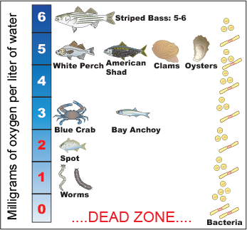 | Based on the the oxygen requirements  Rank the spesies from most sensitive to least sensitive to changes in water quality.  1.  2.  3.  4.  5.  6.  7.  8.
What are the effects of hypoxia?  Low oxygen levels radically alter the ecology of coastal systems. Fish and mobile invertebrates (like shrimp and crabs) can migrate out of hypoxic areas. Plants and animals that are slow moving or attached to the bottom (seagrass, worms, and clams) cannot escape from the dangers of hypoxic water and will die with extended exposure. | Which organisms would be affected most by hypoxia?
What types of dead zones (hypoxia) exist?  Different water bodies can experience hypoxia for long or short periods. Scientists classify water bodies in four broad categories: Permanent, temporary, seasonal, and diel cycling. Permanent hypoxia occurs in very deep waters where oxygen rarely rises above 2 milligrams per liter. Temporary hypoxia exists for hours or days Seasonal hypoxia occurs every year, but only during the warm months. Diel cycling hypoxia occurs in warm months, but only during the night | The following graphs show hypoxia, use the definitions from the paragraph and classify the graphs as permanent, temporary, seasonal and diel.
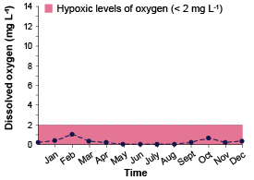 | 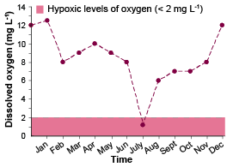
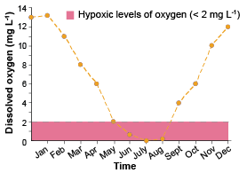  . | 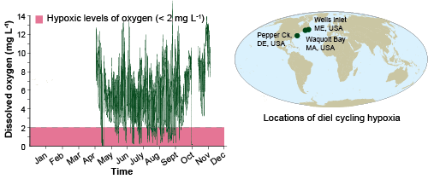
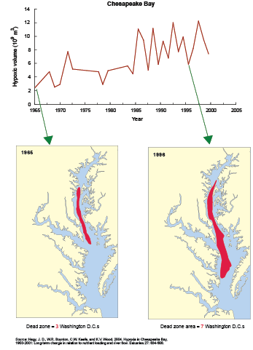 | Chesapeake Bay : Dead zone data analysis  What was the hypoxic volume in the year 1990?  Which year has the lowest hypoxic volume?  How can you describe the hypoxic trend in the Chesapeake bay?  Using the maps and compare the size of the dead zones between 1966 and 1996.  Using this data evaluate the water quality of the Chesapeke bay for 1966 and 1996 .

Application and synthesis
- The Chesapeake Bay has seasonal hypoxia. Sturgeon is fish species that is native to the Chesapeake Bay. The Chesapeake Bay sturgeon populations have declined drastically. A sturgeon restoration scientist is planning to release thousands of young sturgeon in the Chesapeake Bay to increase the sturgeon population. Sturgeons are bottom-feeders, so they typically live in bottom waters. What factors should the scientist consider in planning when to release the sturgeon?

- What would happen to dead zones if a hurricane occurred? Why?

- Write a paragraph explaining the relationship between Dissolved oxygen, water temperature and photosynthesis.

