Managing the impacts of climate change and farming on water quality
Background
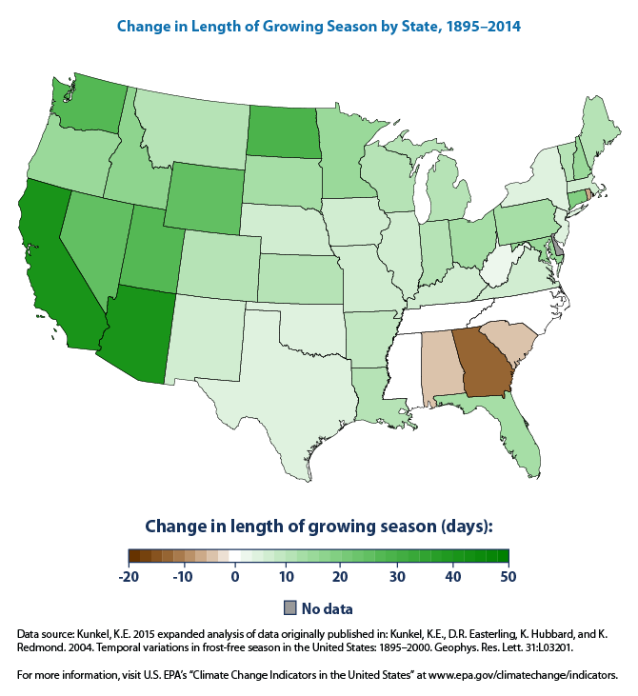
Growing season is the number of days when plant growth takes places and its length and it depends on the climatic processes like, air temperatures, frost days, rainfall, or daylight hours (1). Climate data shows that the growing season has increased in most parts of the United States especially in the Chesapeake Bay watershed. It is possible that with the longer growing season farmers could diversify crops or have multiple harvests and as a result increase the demand for irrigation and increased fertilization. More nutrients could enter the Bay as a result of changes in climate and changes in farming practices. Which in turn could affect the Chesapeake Bay’s ecosystem and policies that protect the ecosystem.
Figure 5: Change in length of growing season
The EPA under the Clean Water Act has set TMDL (Total Maximum Daily Loads) for pollutants entering the Chesapeake Bay from its watershed. The limits are as follows
- 185.9 million pounds of nitrogen
- 12.5 million pounds of phosphorus and
- 6.45 billion pounds of sediment per year

Assignment
Research a particular Best Management Strategies (ways to reduce the amount of pollutants) and prepare a poster to present facts and persuasive arguments. Limit the poster to ONE poster size sheet.
Best Management Strategies (BMP)
Streamside Buffers Streamside Fencing Nutrient Management Plans (NMPs) Continuous No-Till Cover Crops
Each poster must include the following information:
- Complete description of the Best Management Strategy
- What is the main goal of the Strategy
- How effective is this strategy in reducing pollution?
- What are some advantages and disadvantages of this strategy?
- Also include current events, news stories or magazine articles that are relevant to your strategy
Poster must have . . .
- Be sure to include graphs, diagrams, pictures and drawings of your strategy. Make sure the source is documented.
- Typewritten information in no less than 12-point and no more than 14-point font

Best Management Strategy Project Rubric
Name: _____________________________/ Partner: ____________________________

Topic: ________________________________________________

Poster includes:
- A clear, concise description of the strategy and how it works ______/10 pts

- Pictures or diagram of the strategy is included_______/5 pts

- Poster is interesting and easy to read _______/5 pts

- Current research/article or case study is included in discussion ______/5 pts

- Poster shows how the strategy is used/data is presented ______/5 pts

- Advantages and disadvantages are presented ______/5 pts

- Spelling, grammar and neatness _____/10 pts

- Team work _______/10 pts

Total score _________/50 pts

Comments:

